Welcome to Coastline!

To help you get started with your teaching assignment(s), we would like to let you know about the support that is available to you. The members of the Office of Learning & Instructional Technology (OLIT) are here to help you design, develop, and deliver a quality course both in the classroom and online. The three essential tools you will use at Coastline are: MyCCC, Seaport, and OWA.

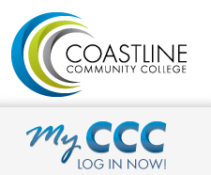
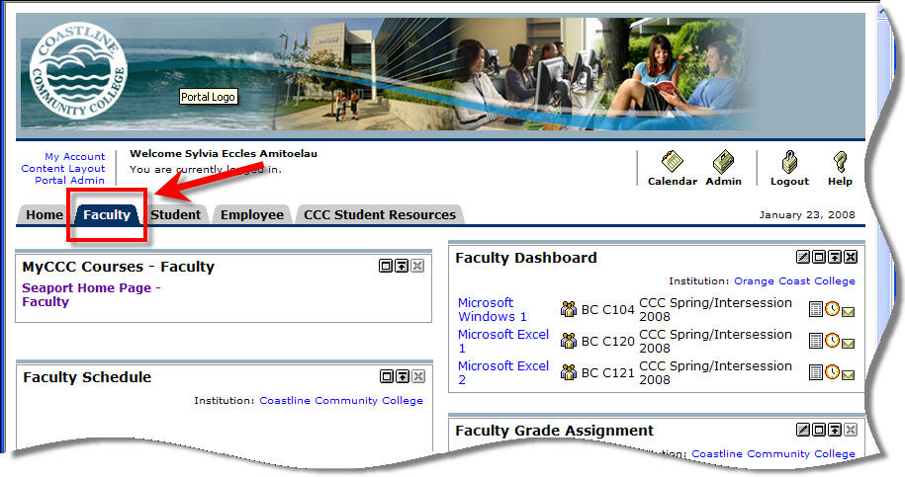
MyCCC is Coastline’s Internet portal system for Coastline students, faculty, and staff. MyCCC login site: http://coastline.edu

Faculty can use MyCCC to:
- Access up-to-date rosters
- Retrieve Add authorization codes
- Drop students
- Submit final grades
- Report positive attendance
- Obtain students’ email addresses, phone numbers, and mailing addresses

MyCCC Password Support is available:
Monday – Thursday 8 a.m. – 5 p.m. and Friday 8 a.m. – 2 p.m.
(714) 241-6176 (Have your employee ID ready)

Seaport is Coastline’s Course Management System. All Coastline courses automatically have a course website. In addition to accessing rosters and e-mailing students, you can use Seaport to provide students with:
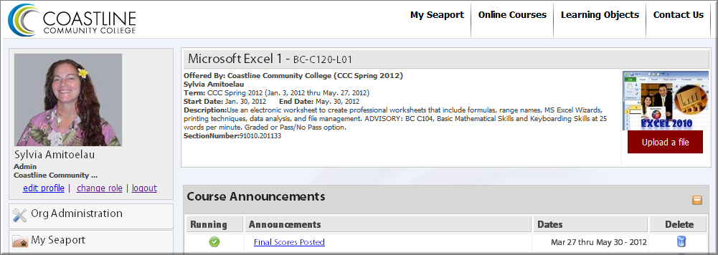
- Instructor contact information
- Syllabus (webpage or file to download)
- Handouts (Word, PowerPoint, etc.)
- Links to videos, audio, websites, etc.
- Online testing
- Grade book
- Discussion Forum
- Announcements
You can access Seaport from MyCCC or you can login directly to Seaport at: http://seaport.coastline.edu
Coastline E-mail OWA (Outlook Web Access). It is college policy that faculty use their @coastline.edu e-mail for all official college business. Contact your Area Facilitator for your OWA user name and password information.
OWA login site: http://owa.coastline.edu

Training & Resources & Help Requests
The OLIT Faculty and Staff Resources website where you will find current help documents for using Seaport and MyCCC, video tutorials, and many more valuable resources.
- Go to the Coastline College home page at http://coastline.edu
- Click Faculty & Staff (at the top)
- Click OLIT Faculty/Staff Support (on the left)

OLIT also provides other services such as:
- Brown bag seminars
- Summer Institute: a two-day workshop highlighting technology in learning
- Web conferencing with CCC Confer
- Video and audio recordings
- Software assistance with products such as Camtasia and SnagIt, and basic graphics.

The Office of Learning & Information Technology:
Lynn Dahnke, Manager
Sylvia Amito'elau, MSIT
Mark Worden, MSIT
Meg M. Yanalunas, MSE

